Evora developer documentation
The game is designed using MVC model. Model contains the game data and is controlled using controller.

Model
The model contains all the data representing the current game state.
The model data structure:
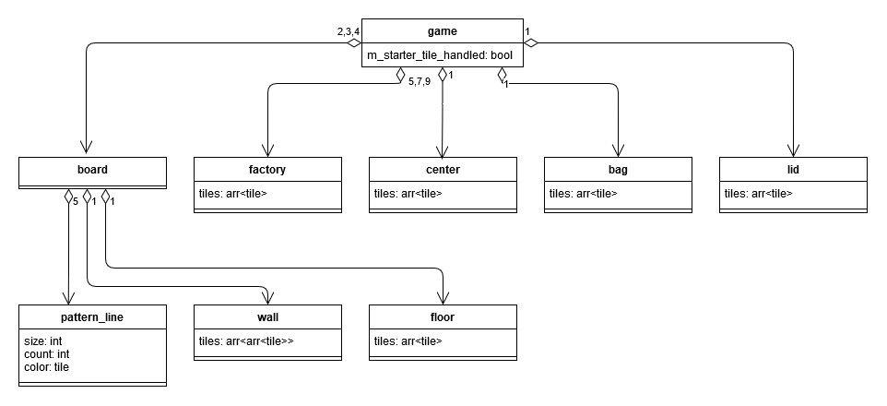
The tile is represented by an enum and can have any of the following values: blue, yellow, red, black, white, empty or starter.
All the methods on the model are called from the root game class.
In the GUI there is also a wrapper for the game class that takes care of updating the view whenever a state of the game changes.

Controller
The controller contains a reference to model. All the changes on the game happen using the command class that has an execute and unexecute methods. Execute method moves executes a given command, unexecute moves back.
The two most important methods in controller are step(void): bool and add_command(unique_ptr<command): void the step methods progresses the game one step further, e.g. executes a single command that a command pointer currently points to and moves the execution pointer to the next command. The step method also checks whether the round is over and whether the game is over and adds commands accordingly. When executing commands, The add_command method ads a single command it receives as an argument to the top of the command stack.
The control class can also provide a list of all the possible moves in a current game state. It can be done by invoking the command get_possible_moves(int):std::vector<std::unique_ptr<command>>.

Commands
There are 11 classes that inherit from the command class.

Start of the round commands
init_round
Draws tiles from the bag and puts them to factories. If needed, also refills the bag from the lid.

Commands for player interaction
factory_offer
Move tiles of a selected color from a selected factory and put them on a selected pattern line.
drop_factory
Move tiles of a selected color from a selected factory and put them on a floor.
center_offer
Move tiles of a selected color from center and put them on a selected pattern line.
drop_center
Move tiles of a selected color from center and put them on a floor.

Wall tile phase commands
score_wall_tile
Calculate score for a given tile on the wall and adds the score to the appropriate board.
tile_wall
Move a tile over from a pattern line to the wall, move remaining tiles to the lid.
tally_floor
Calculate the score for the tiles on the floor, add it to the appropriate board and move the tiles to the lid.

End of the game commands
score_line
Score a line of a wall at the end of the game according to the rules.
score_row
Score a row of a wall at the end of the game according to the rules.
score_color
Score a color of a wall at the end of the game according to the rules.

View
The view is either a GUI created in godot or a console UI. Aside from displaying information about the game and controlling a game using the controller object, view class is also responsible for keeping tabs on players, whose move it is currently and switching between players when their move is over.

